CLOSTER HISTORIC PRESERVATION COMMISSION
295 Closter Dock Road
Closter, New Jersey 07624
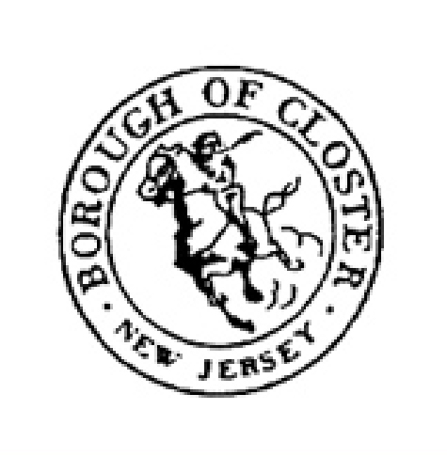
Closter Mayor and Council
Borough of Closter
295 Closter Dock Road
Closter, NJ 07624 August 4, 2009

Re: Report on Designation Hearing for the West Street/Harrington Avenue District

Dear Mayor Heymann and Council Members:

On August 3, 2009, the Closter Historic Preservation Commission held a special meeting and hearing for the nomination of the West Street/Harrington Avenue District. After Doug Radick opened the meeting, he disqualified himself from the proceedings, as he owns a house in the proposed District. Ms. Irene Stella commenced the hearing. All members of the Commission were in attendance with the exception of Tim Adriance. Mr. Eric Bal acted as the Commission’s attorney. Mr. John Kashwick, liaison to the Council and Mr. Andy Ouzoonian, liaison to the Planning Board, were present.

Ms. Stella reviewed the Nomination Report for the proposed West Street/Harrington Avenue District (attached). She then introduced Ms. Bobbie Bouton Goldberg, who described the research efforts contributing to the findings in the Report. Ms. Jayne Rubenfeld-Waldron spoke about her experiences owning and renovating a designated home. Ms. Rothschild commented about the architectural integrity of the District. Ms. Stella then opened the meeting to the public for questions and comments. There were eight persons in attendance. Mr. William Cahill of 248 Harrington Avenue spoke. He stated that both he and his family whole-heartedly appreciate the efforts of the Historic Preservation Commission and welcome the level of zoning protection that designation of the District would afford. He stated that it is something that will keep the neighborhood as it was and has been for many years to come. There were no other comments from the public.

Upon closing the meeting to the public, Ms. Stella asked for discussion among the Commission. Mr. Kashwick and Mr. Ouzoonian expressed appreciation for the diligent work of the Commission. There being no further discussion, Ms. Stella asked for a motion.
RESOLUTION:

WHEREAS, the Closter Historic Commission’s duty is to safeguard the heritage of Closter by proposing to the Borough’s Council those buildings, structures, objects, sites and districts located within the Borough which it has found to be worthy of landmark designation, in order to preserve resources within the Borough which reflect elements of its cultural, social, economic, and architectural history, and

WHEREAS, the neighborhood known as the West Street/Harrington Avenue District as mapped and described in the Nomination Report and comprised of 28 properties identified by their street address and block and lot numbers, meets the criteria for designation as set forth in Closter Code Section 35 et seq. in that it is associated with events that have made a significant contribution to the broad cultural, political, economic, or social history of the community, specifically as a railroad suburb arising after the arrival of the Northern Railroad in Closter in 1859, and

WHEREAS, this District is associated with historic personages important in shaping Closter’s history, and

WHEREAS, as a District, this neighborhood represents a significant distinguishable entity whose components may lack individual distinction, and

WHEREAS, there was no voiced or written opposition to this nomination and there was voiced public support for the proposed District,

THEREFORE BE IT RESOLVED that the Commission will forward to the Closter Mayor and Council its Nomination Report for the West Street/Harrington Avenue District and its recommendation that this District be included in Closter’s list of historically Designated properties under Closter Code Chapter 200 (Zoning).

Introduced by: Jennifer Rothschild
Seconded by: Bobbie Bouton Goldberg

Adopted on August 3, 2009, on roll call vote as follows:

Ayes: 6
Nayes: 0
Recused: 1 (Radick)
Absent: 1 (Adriance)

Signed_____________________________________
Irene Stella, Acting Chairperson

Attachments: Nomination Report
District Map and List of properties

