Nomination Report for Historic Designation
of the
“Village School”
Block 1316, Lot 9
Closter, New Jersey

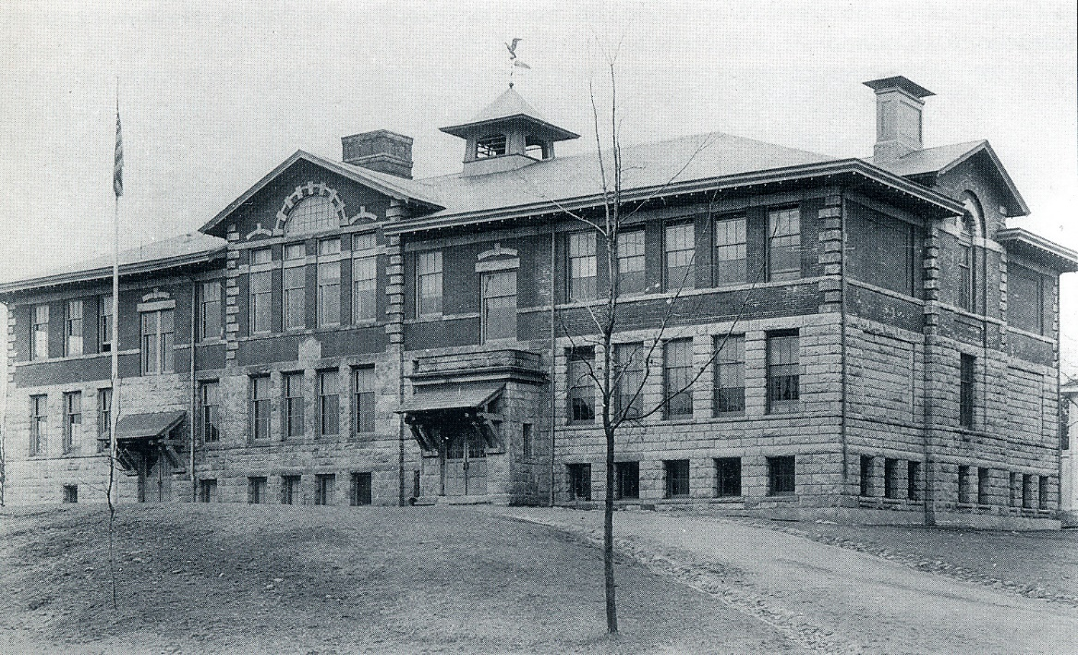

Prepared by
The Closter Historic Preservation Commission

Tim Adriance, Chairman
Jennifer Rothschild, Vice Chairman
Bobbie Bouton-Goldberg
Erik Lenander
William J. Martin, AIA
Susan McTigue
Orlando Tobia
Jayne Rubenfeld Waldron
Joel Zelnik

May 20, 2017
(Revised June 27, 2023)

LOCATION:

511 Durie Avenue

Block 1316, Lot 9

40° 58’ 18.12” N, 73° 57’ 48.58” W

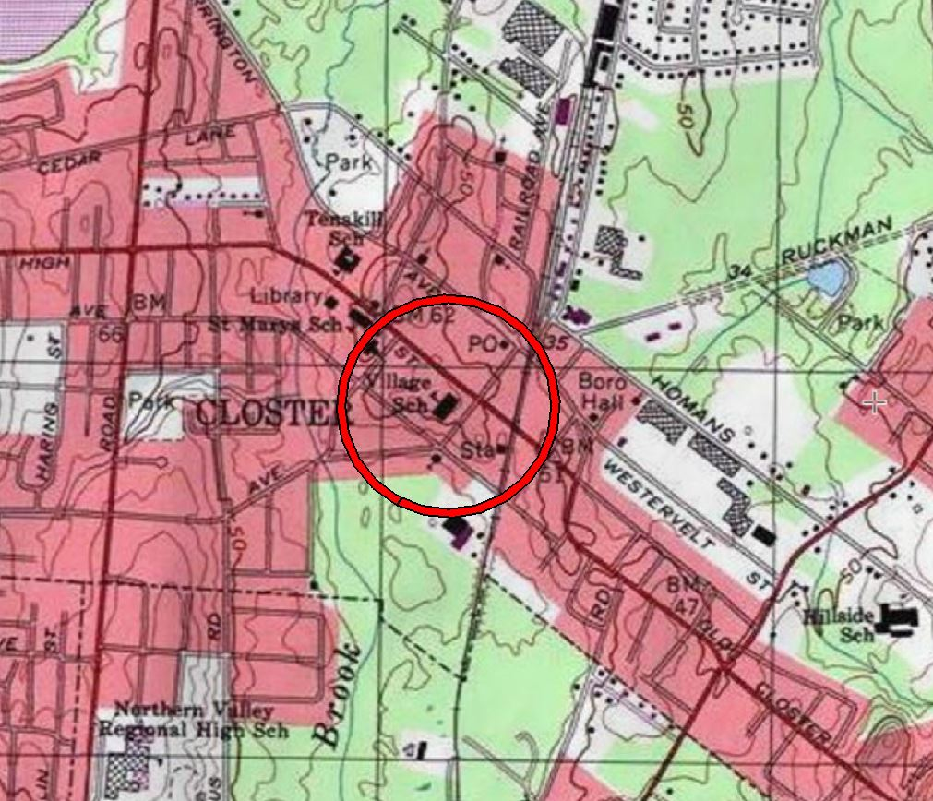

United States Geological Survey Map showing location of Village School

HISTORY:
History section prepared by Tim Adriance

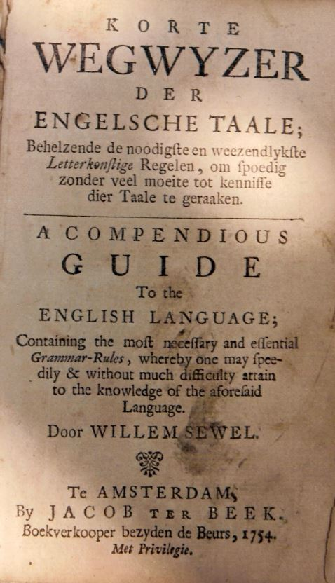
Education has always been important to the people of Closter. From its earliest settlement starting in April of 1710 by Barent and Resolvert Nagle we find people who were literate. This is attested by fact that Resolvert Nagle was able to sign his name to a December 15, 1743, deed, whereas his wife Claertie Nagle could only make a mark with two rudimentary letters (and her letter “N” was written backwards). A quest for learning was important for the early Closter settlers as they were forced to abandon their native Dutch language and assimilate into the English-speaking world. This learning likely took place at home by the light of the fireplace hearth using such helps as the 1754 book Korte Wegwyzer Der Engelsche Taale (A Compendious Guide to the English Language), a copy of which existed in the possession of the Auryansen family of Closter. The educating of children in the earliest days of Closter was performed in the home, and later in a more organized fashion in a space created for or repurposed for schooling. The c1710 home of Barent Nagle which stood on the north side of Harvard Street (at about the location of 21 Harvard Street) was once used as a school.
Earliest known “textbook” used in Closter.

Closter did not become a borough until January 1, 1904 and prior to that date it was part of Harrington Township. Historically Closter was an area much larger than today’s borough limits (sources indicate everything from Liberty Pole in Englewood to Tappan was once considered to be “Closter”), and as such the first teacher using English in Bergen County, Benjamin Blackledge (1743-1815), is said to have been from “Closter,” although early deeds indicate he lived in what is now Demarest. Blackledge used part of his dwelling as a schoolhouse for people in Harrington Township. The earliest official school for Closter children once existed on the east side of Piermont Road one quarter mile north of Blanch Avenue. Prior to 1830 classes were held here in a stone building owned by Moses Taylor. In 1830 Mr. Taylor formally leased this portion of his property to Harrington Township to be used for a school, and a wood schoolhouse was constructed. The building was still standing in 1912.

In 1864 the basement of the Reformed Church of Closter was used as a schoolroom, the teacher was Belle E. Hammond daughter of Reverend Hammond. By 1875 Belle E. Hammond was running a full-fledged school known as the “Closter Institute” which taught English, French, German, and music and was assisted by “an able corps of teachers.” The school was located at about where 22 Legion Place stands today and could accommodate 50 students and had an average attendance of 40.

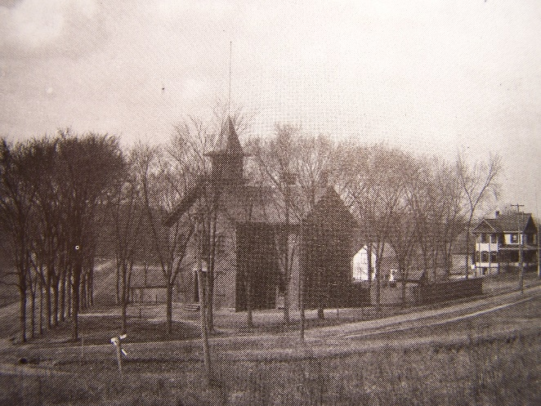
In 1871 the first public school building in Closter village (the newer west side of town, school District #15 of Harrington Township) opened, with a construction cost of $9,000. Known as Harrington Township Public School Number 2 the four-room brick building still stands at the corner of Durie and Demarest Avenues. During the construction of the school in 1870 classes were held in the Van Ostrand barn on High Street. Progressive ideals flourished in Closter at this time and the student body of the school was fully integrated. In 1894, it was noted that the school had a capacity for 128 students and was valued at $5,000. A cast iron bell for this school was cast in 1887 by the Buckeye Bell Foundry, Vanduzer and Tift of Cincinnati Ohio.
Harrington Township Public School Number 2

By 1898 the population of Closter was growing to such a degree that old school #2 was becoming overcrowded, in addition there was a call to expand the number of grades. On July 8, 1898, the Bergen Democrat reported that the Closter Board of Education, acting at the suggestion of county School Superintendent John Terhune and with a majority support of the voters of Harrington Township, “decided to establish a class in the Closter school for the entire township, where the ninth and tenth grades can be taught, in order that those who may be disposed to take that course of study can go to any high school in the county.” The Board of Education was prepared to provide all the necessary needs to that end. Up to the time that this determination was made, many Closter students graduated school at the 8th grade (at about fourteen years of age). Parents who chose to further their children’s education had to send them to Hackensack High School or elsewhere, but most could not afford to send their children. The Board's new ruling provided two years' additional education here in the local Closter school. However, it became immediately apparent that there was a strong need to increase the size of the educational facilities. A year later, on August 25, 1899, the newspaper, the Bergen Democrat announced that the Harrington Township Board of Education had called a meeting for “Tuesday next” (August 29, 1899), “to vote on the question of erecting new schoolhouses at Closter and Harrington Park. The proposition is to spend $13.500 in Closter and $5 000 in Harrington.” On, September 1, 1899, the Democrat reported the outcome:

CLOSTER

The people of Harrington Township have at last definitely settled the school question, and the township will have new school houses. At the meeting on Tuesday night, in Ward's Hall the following propositions were adopted by a vote of 106 to 22: That a plot be purchased in Closter, 225 feet on High street and 305 feet on White street, at a cost not exceeding $3,000. This plot is the property of the Bloomers, of River Edge. That the Board Of Education be authorized to erect a school building to contain three class rooms and an assembly room. To be built of brick, or stone or a combination of the same. The cost not to exceed $10,000. The sum of $500 is voted for the grading of the plot. In Harrington Park four lots were ordered purchased, at a cost not exceeding $600; on this property a school house containing two class rooms and an assembly room is to be erected, the cost not exceeding $1,500. The Board of Education is directed to procure the necessary funds by issuing bonds to the extent of $15,600, and of the following denominations: one bond for $600, eighteen for $500, and nine for $1,000 each, with interest not exceeding five per cent per annum. The first bond will fall due in 1905, and $1,000 shall be paid each year thereafter.

On August 29, 1899, E. H. Schuyler, president of the Board of Education of Harrington Township, entered into an Article of Agreement with Anderson Bloomer, George Bloomer, David N. Bloomer, and Emma Bloomer, all residing in Palisade Township, the heirs of Mary Ann Bloomer (widow of George Bloomer, Sr.), deceased, to purchase four tracts or parcels of land in the Village of Closter. These designated as Lots numbered One, Two, Three, and Four in Block Five on a Map of the property of David A. Demarest at Closter, made by George P. Hopkins, Surveyor, and filed in the Bergen County Clerk's office. The whole of said lots taken together as- one parcel were butted and bounded as follows:

“Beginning at the Northeast corner thereof at the intersection of the Southerly side of High Street with the Westerly side of While Street and running thence (l) Westerly along the Southerly side of High Street 225 feet to the corner of lands of Meyer: (2) Southerly along the lands of Meyer 305 feet to the Southerly line of the farm of the late David A. Demarest; (3) Easterly along the line of the farm of the late Mathew S. Bogert 225 feet to a point in the Westerly side of White Street; thence (4) Northerly along the Westerly side of White Street 305 feet to the point or place alone of beginning: bounded north by High Street, east by White Street, South by other lands of the parties of tile first part, and west by lands Meyer. These were the premises which were conveyed by Thomas W. Demarest and his wife to Mary Ann Bloomer by deed - dated February 16, 1863, and recorded in Book R5, page 392. The Board of Education agreed to pay $3,000 for these lots: $100 upon the Article of Agreement and the balance of $2,900 on or signing before the first day of December 1899, together with the interest thereon at a rate of 6% from September 1, 1899. In keeping with this agreement, Anderson Bloomer, George Bloomer, David N. Bloomer, and Emma Bloomer, all of Palisade Township, the heirs of Mary Ann Bloomer, deceased, released the aforesaid four lots to the Board of Education of Harrington Township on November 17, 1899.”

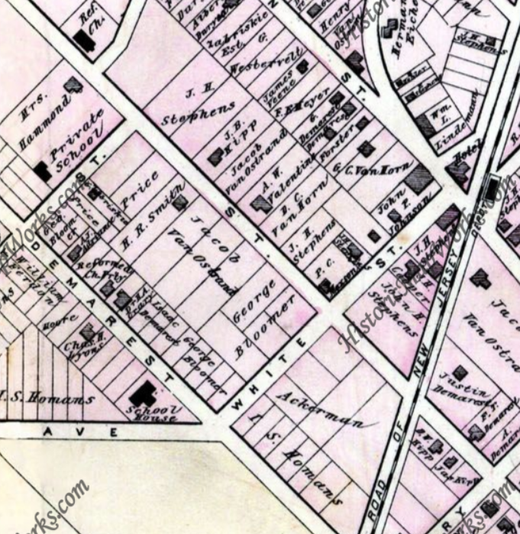
Pease-Walker 1876 Atlas of Bergen County showing the four lots of George Bloomer
In September 1899, County School Superintendent John A. Terhune stated in his Annual Report to the State Superintendent that voters had approved bonds to fund a new $13,500 school building at Closter. On March 2, 1900, The Bergen Democrat noted: “Edgewater, Westwood and Closter are about to build $10,000 schools.” Construction did not start until July, when the newspaper finally announced that “Work on the new school houses at Closter and Harrington Park has commenced.” The new building was not finished by the opening of school that fall and in his Annual Report, released in September 1900, County School Superintendent Terhune stated that “The two new buildings in Harrington Township, to cost $20,000, are not yet completed.” When the school was finally finished in 1900, students from kindergarten to eighth grade attended. To “finish” the new school the bell from the old school down the street was installed in the cupola. The cupola was topped with a copper eagle weathervane which had a writing quill at its bottom. The weathervane is thought to have been designed by local sculptor J. Massy Rhind. Rhind is best known for his work on Grant’s Tomb and the doors of Trinity Church in Manhattan.
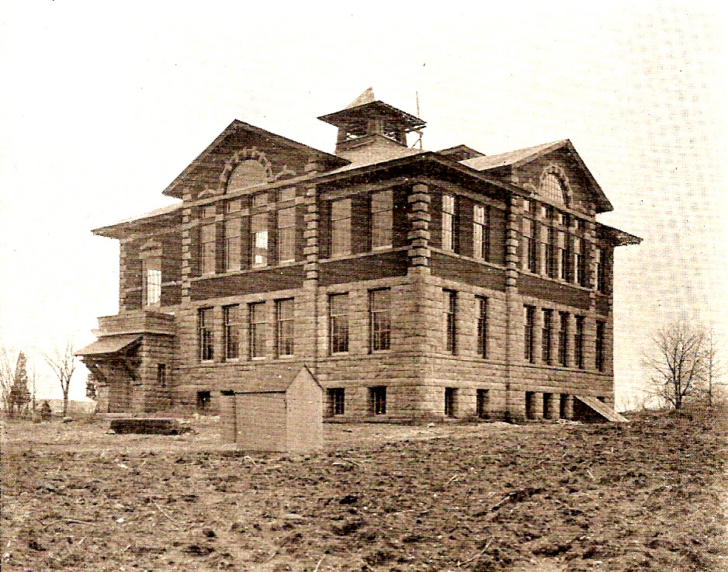

Closter Public School at completion of construction in 1900

On April 13, 1903 the process to establish the Borough of Closter began with the Public Law 1903 Chapter 161 and ownership of the Harrington Township schools in what is now the Borough of Closter were transferred to the borough’s newly formed Board of Education under Public Law 1903 (2nd Special Session) Sections 48 and 49. As a side point of interest, the last borough to be created from Harrington Township was Norwood which was established on March 14, 1905.

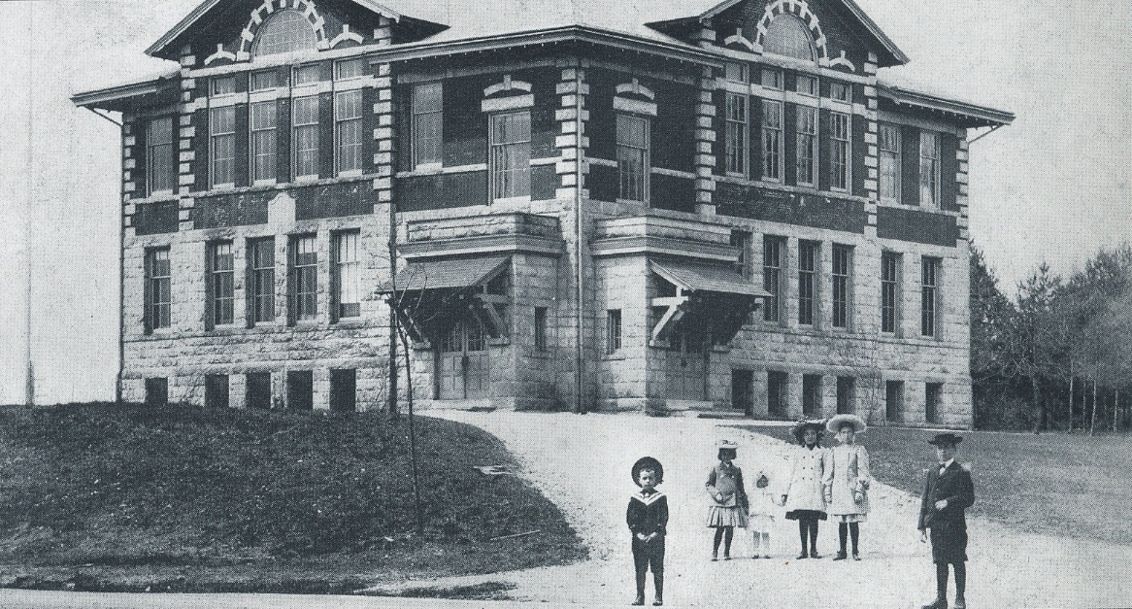

1902 view of the Closter Public School with Dorius, Inez, and Stanley Taveniere; Hazel Johnson; and Walt Herron.

On April 5, 1906, the Perkins Act became law, creating a State franchise tax upon railroads. It generated a considerable amount in new revenues for the support of the public school system, particularly for the purpose of providing a free high-school education.

The following public notice appeared in the Bergen Democrat:

Notice to Builders, Contractors, Etc.
BOROUGH OF CLOSTER

SEALED PROPOSALS will be received by the undersigned. Chairman, of Building and Grounds Committee of the Board of Education of the Borough of Closter, at his home in Closter, on or before Monday evening, Nov. 5, 1906, at 7:45 o'clock. For building an addition to the present new school building.
Plans and specifications may be seen at the home of said Chairman on and after Oct. 5th, 1906.
All bids will be unsealed and the contents publicly announced at a meeting of the Board to be held at the Board room on Monday evening, Nov. 5th. at 8 o'clock.
The Board reserves the right to reject any and all bids.
E. QUACKENBUSH,
Chairman
The Closter Public School was enlarged toward the south by an addition of four classrooms in 1907. The newspaper, Bergen Review of December 27, 1929, claimed that “two additions were added (to the Closter Public School), one on the south and one on the north end,” previous to 1912. The north addition was actually built in 1912. (The south addition was removed on May 24, 2018.)

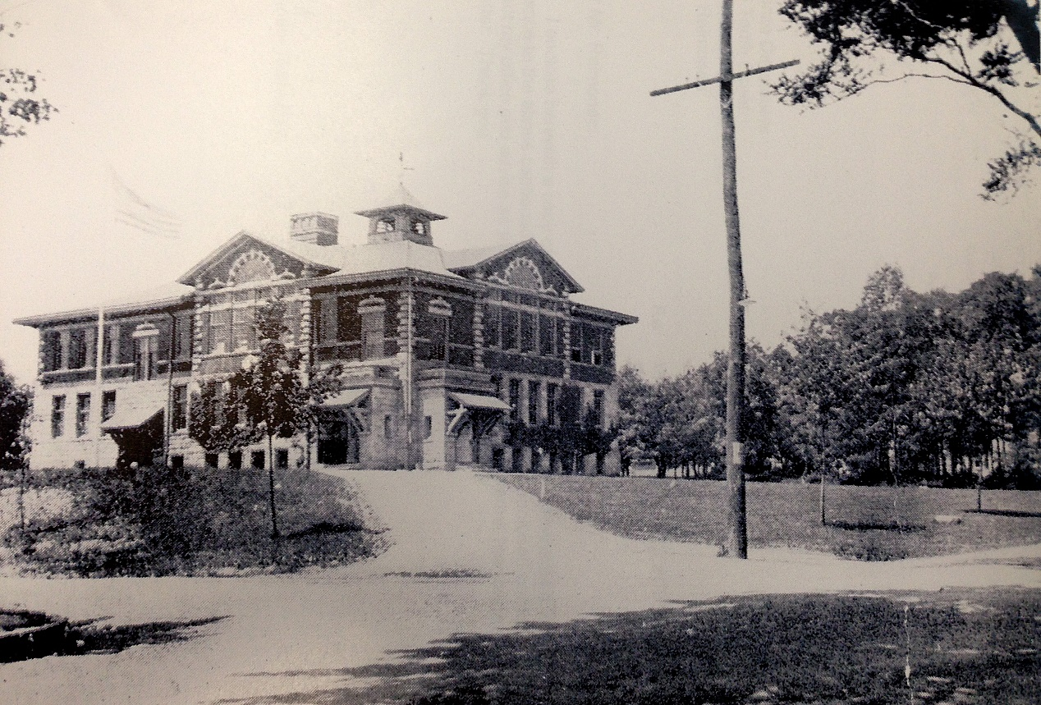
Pre 1912 view of the Closter Public School, note the large American flag proudly waving from the flagpole.
Closter received approval to establish a four-year high school curriculum in 1911. On August 25, 1911, Closter voters were asked to choose between “a six-room addition to the present school building, according to plan submitted by Architects Guilbert & Betelle” or “a six-room addition to the present school building, according to plan submitted by architect A. G. C. Fletcher.” Either design was to be built at a cost not to exceed $22,000. Architect Fletcher's design, including six additional classrooms, a board room, and teachers' room, built with brick and stone on the north side of the existing building, was approved. It was built in 1912 at a cost of $75,000.

1912 view of the Closter Public School

On June l. 1914, the Closter Board of Education asked its Clerk to write to the County Superintendent of Schools requesting his cooperation in securing enrollment of high school students from adjacent boroughs. In an effort to protect the students, fire-escapes were added in 1918.

Another $75,000 addition was built to the Closter Public School in 1921, this time to the far south end of the school, and the original auditorium was restored by the removal of four classrooms that had been created in the space. The new facilities, including two rooms on the first floor of the new addition and all new lavatories, were available for the opening of school on September 12, 1922. A railroad strike delayed work on the remainder of the new addition and was expected to be completed by October 1st. The new addition also included a gymnasium. Vines were to be planted on the exterior to conceal “concrete work which had been substituted for stone so as to economize.”

With the need for more classroom space to accommodate the growing population of children, Closter voters on July 19, 1927, approved the purchase of a tract of land, bounded north by Main Street (now Harrington Ave.), east by land of the Palmer and Tate families, south by High Street, and west by the Tenakill Brook. On August 20, 1928, the Closter Board of Education engaged Lee and Hewitt, school architects, to draw the plans for the proposed new building on the recently acquired lot on Main and High Streets. They also decided to remodel and re-arrange the interior of the present schoolhouse, to be used for “Junior and High School purposes,” at a cost not to exceed $10,000. In 1929, the primary grades were moved from the Closter Public School to the new Tenakill School. On June 4, 1929, Lee & Hewitt, architects, were employed as consultants “relative to the alterations to be made in the old school building.”

When the Tenakill Grammar School opened in 1929 on High Street, this school became the Closter Junior-Senior High School from 1929 to 1955 when the new Northern Valley Regional High School was opened in Demarest. At this time a contest was held in the school to decide a new name for the building, with a pen and pencil set as the prize. The winning student was Vicki Mall Shropshire who entered the name “Village School.” The name was actually suggested to Vicki by her grandmother’s, Mrs. Browne (wife of a former Mayor), because the old timers called the downtown “the village.” By 1982 then Superintendent of Schools William Hanley and the Board of Education formed a committee of staff and community members to study the Village School and its shortcomings. The committee recommended that the school be closed due to its inadequacy. When Mr. Hanley retired, the new superintendent, former Tenakill principal Jeffrey Feifer, inherited the task of closing the Village School. This decision was met by a hue and cry of outraged residents who had fond memories of the school. Upon the closing of Village School, Hillside School and Tenakill Middle School absorbed the student population of the former school.

The Village School was the place of education for Closter’s children for nearly a century when it closed in June 1996. The bell was rung for the final time on the last day of school, and both the bell and weathervane were moved to the foyer of Tenakill Middle School to be preserved as testaments of Closter’s rich educational history. But it was in these hallowed halls of The Village School that reading, writing, mathematics – and American history were taught. And here with Old Glory waving proud from the flagpole Closter young boys; Leroy S Mead, Anthony Brodil, Arthur Buzzoni, Frederick G. Maycock, Herbert Bowers, Edward R. Asmus, Jr., Andrew B. Carr, William M. Carr, John L. Durant, Rino Giletta, Edwin Goodwin, Walter L. McCain, Jr., Charles H. Parsells, William D. Wilson, James J. Amendola, Donald A. Mollicone, Kenneth Schauble, and James O’Shaughnessy learned the value to give the last full measure of devotion in dying for their country in World War I, World War II, and Vietnam.

The Village School was sold by the Board of Education of the Borough of Closter on October 4, 1996, to Kitty Fan Koo Irrevocable Inter-vivos Trust, under a trust agreement dated December 20, 1989, Lei Chen Fan and Lei Min Fan, Trustees for $800,000.00. Since that time the building has sat vacant.

The school building is recognized by the County of Bergen as a historic site and is included in the 1985 County of Bergen Historic Sites Survey. The Bergen County Historical Society recognized the school building as a historic site in 1999 with the erection of a historic marker after a thorough and extensive report by the late historian Kevin Wright confirming the history of the school was completed. The marker was sponsored and paid for by the “The alumni and friends of the school.”

DESCRIPTION:
Closter Village school exterior description prepared by William J. Martin, AIA

The Village School is located not far from the original “downtown” area. The shape of the land is essentially a pedestal hilltop and is among the highest points in the local landform. Viewed from below as one approaches, the building appears impressive and formal from a distance and becomes softer and inviting as one gets closer. This is exactly what a school building design should communicate. This was a nurturing place for children to learn surrounded by a strong and safe sheltering exterior.

The plan layout of the building is a series of connected square and rectangular forms. These plan shapes reflect the history of the building as having been built with an original main section and then a series of added wings.

The general massing of forms at the Village school building is a one-half story high stone portion with an exposed basement below first floor classrooms and then topped by a brick section with second-floor classrooms. The wood framed, masonry exterior building has a framed roof shape that is a sloped hip style with generous overhangs and prominent roof gables facing Northwest, Northeast and Southeast. The original 1900 building is capped with a pyramidal belvedere bell tower containing a dramatic flared eave. The bell itself has been relocated to another Closter School.

The Closter Village School actually consists of a variety of architectural expressions. This is common when buildings are constructed and then added to or modified later to accommodate additional functions. Earlier portions are expanded and modified with a respect for the original. As times and styles change, the added portions reflect a more modern expression.

Most notably the original 1900 portion of the school building contains more classical elements. The two-story Beaux Arts building includes interesting elements such as the combination of Renaissance motifs and Colonial Revival design. The building once contained an addition to the South (technically Southwest). This addition was added later and did not match with the original 1900 building façade. While these two expressions did not blend well, they were a true reflection of their historical periods. The South wing expressed a more midcentury simplified architecture. The South addition was removed on May 24, 2018.

On the original, stone blocks that create the first-floor base connote a sense of strength and permanence. The stone was quarried locally, and the brick was transported by railroad from other areas. The upper floor displays a formal, solid and void, classical exterior with divided panels. The change in wall material from the first floor to the second floor creates a balance between rustic and ordered forms. This was an artistic technique used to visually reduce building height by combining the basement and first floor in one material while making the second floor seem visually shorter than its actual height.

The rusticated stone base extends from the grade to the head of the windows of the first floor. At the second floor above this rusticated stone is a combination of brick and stone architectural features. Stone bands run above and below the second-story windows. The stone sill and lintel frieze banding breaks up the second level façade into 3 horizontal brick sections with windows punched through the mid-section. Arched forms and stone coins are incorporated into projecting corners around the older original sections of the exterior.

There is a spline curve stone marker just above the first-floor lintel stone below the Southeast gable that proclaims “Closter Public School Erected 1900.”

Generally speaking, the windows are large and generous. Old photos of the school show the original 1900 building had cottage style double hung windows with a large lower sash and a smaller upper sash typical of the cottage style. An early form of air conditioning, the smaller upper sash could be opened to allow hot air to escape out of the classrooms on warm days. Opening the upper sash only caused a convective air current as the rising hot air escaped. This allowed cooler air to be drawn into the classrooms from the interior halls or through the lower sash which could be opened in classrooms on the shady sides of the building. Light colored shades were used on the windows to control the heat gained through sun exposure.

Since the original construction, the windows have been replaced with tall rectangular double hung windows with fixed transoms above.

The basement windows are double hung and more square in shape. These align with the first-floor rectangles above. The second-floor windows also align with windows below in ordered and rational locations. Some second-floor windows, aligned below the roof gables of the original building, have a detached upper transom configuration accented with masonry arched features above. The roof gables themselves had a circular half round window that has been replaced with a solid panel. The Northeast façade with centered gable contains minimal windows. This façade displays a main circular brick arch with a concentric stone arch. This is surrounded by stone quoins at the projected corners. Flanking the Northeast gable at the second floor are rectangular brick panels with stacked and soldier coursed brick with square masonry rosettes. These paneled divisions serve to visually organize an otherwise windowless façade on the Northeast side.

There are several entrances and exits from the building. The two main student entrances are on the Southeast side facing Durie Avenue. The student entrances are recessed into the façade. One entry is flush to the building face and the doors are recessed back. The other is through a stone entry portico that old photographs show had a rustic wooden crossbar awning roof covering the entry steps. This wooden awning was removed at some point in the past. Both student entrances are three steps up from the grade. The entry opens into the school at a mid-level between the basement and the first floor. Once inside the vestibule, there are stairs up to the first floor and down to the basement level.

Being a school, fire safety was of the highest concern. As additions were added to the building, fire exits were also added. There are fire exit stairs from first floor classrooms on the Northwest side of the building. There are two large two story exposed metal framed fire exit stairs from the second floor to the grade at the Northwest side and Northeast sides. Newer portions of the building also have various fire exits from the Southwest side as well.

The roofing existing on the building today is an asphalt shingle style roof. This type of roofing is used today and is common amongst homes in the Closter area. The roofing in 1900 was likely lead coated copper sheets. In the late 1800s, roofing manufacturers were seeking less expensive metal roofing that was compatible with stone, white-painted wood and other types of masonry exteriors. Copper sheets provided the basic strength of the metal. Then roofing manufacturers dipped these sheets of copper into hot lead as a coating. The result of this combination of copper sheets and lead offered a stronger, a lighter, and a less expensive roofing material with no green copper patina to stain adjacent materials. In addition, the two metals allowed for a durable longer lasting roof with more resistance to the growing problem of acidic rain conditions. Tin and zinc were also used to coat copper roofing sheets.

In 1900, the roof gutter system on the sloped roof sections were wood covered metal and built-in at the roof edge. This also created a decorative molding at the roof edge that likely had a cove shape. These types of roof gutters are known as Box gutters, Built-in gutters, or Integrated gutters are a roof drainage system employed in many homes and public buildings dating back to the 18th century. These gutters were incorporated into the roof overhang structure along the roofline and thus were not easily visible from the outside. This gutter design worked very well with more elaborate masonry building designs.

Box gutters employed a combination of wood and metal to construct the body of the system. Wood was used as an external element to construct the shell for the gutters, while sheets of metal were used to line the interior. The gutters usually made use of a sloped bottom to help expedite the flow of water through the gutter. While various metals were used for the interior lining, lead coated copper emerged during the late 19th century as a favored option.

Box gutters were connected through the building overhangs to copper leaders that would discharge the water at grade level.

The roof penetrations around the Box gutters were prone to leakage. Exposure to extreme summer heat and then seasonal winter cold caused stress and would split the metal linings. Leaks in the metal linings cause damage to the wood overhangs and masonry walls below. Long ago the gutters on the Village School were changed to the standard exterior aluminum gutter and leader system in use on the building today.

The roofing materials on the flat roof sections of the Southwest addition were a multi-layer bituminous “built-up” roof system. Storm water on the flat roof areas would be channeled to openings in the parapet wall and drain into exterior wall scuppers connected to leaders that would discharge the excess storm water at grade level.

Just to finish the exterior description, it is not clear that the school in 1900 had indoor plumbing facilities. The later addition included bathrooms on each floor including the basement level.

The Closter Village School is a fine example of school architecture in the Northern Valley area. The rusticated stone masonry and brick with stone architectural details makes this building a significant cultural artifact worthy of historic preservation.

PHOTOS OF FAÇADES (prior to removal of South wing)

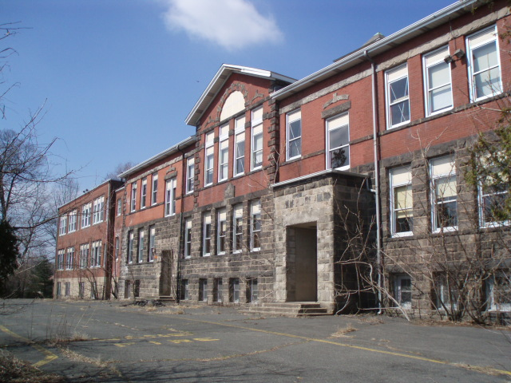

Front façade view from the northeast (note no longer extant south wing to the left)

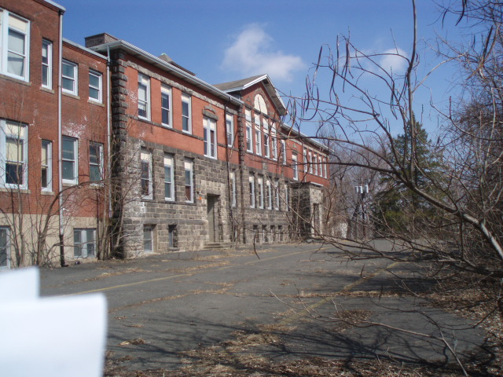
Front façade view from the southeast (note no longer extant south wing to the left)

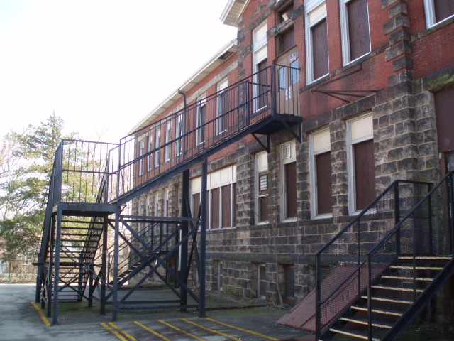

View of the rear (west) façade

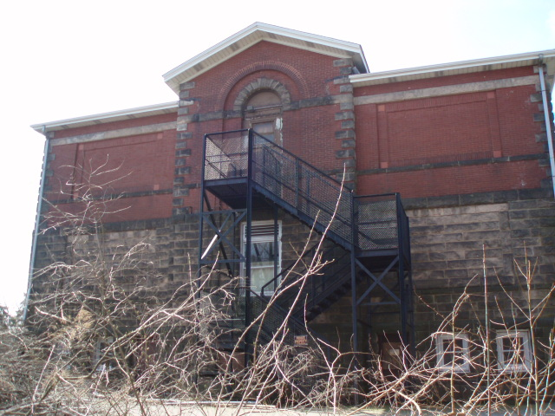

View of the north façade
View of date stone on the front façade
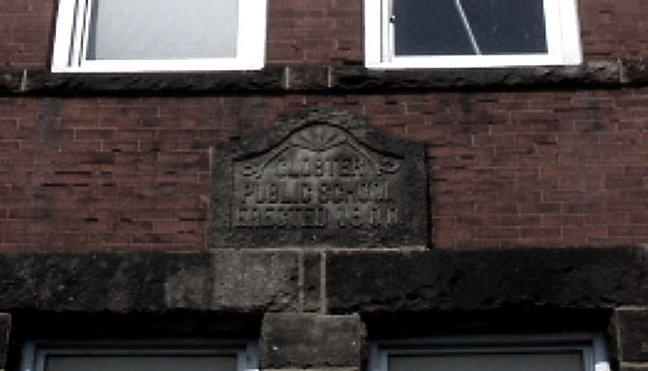
DESIGNATION RATIONALE:

The Village School meets all five points of criteria for designation as set forth within the Closter Borough Code Chapter 35 Section 54 Criteria for Designation.

The Commission considers the Village School as worthy of designation because of its integrity of location, design, setting, materials, workmanship, feeling, and association, and that it meets all five of the following criteria:

(1) That the Village School is associated with the events that have made a significant contribution to the Borough of Closter by reflecting or exemplifying the broad cultural, political, economic, and social history of the community with it being the place of education for generations of the children of Closter for nearly 100 years;

(2) That the Village School is associated with numerous significant personages important in national, state, or local history – including the many significant people who received an education here – but in particular the 18 former students who gave their lives for our country;

(3) That the Village School is the site of the historic events which have had significant effects on the development of the nation, state, and community – namely the education of Closter’s children and the fostering of American culture and values to that populace;

(4) That the Village School as a structure embodies distinctive characteristics of a type, period, and method of construction; that represent the work of master builders; that possess high artistic values; and that represent a significant distinguishable entity whose components may lack individual distinction;

(5) That the Village School is of particular historic significance to the Borough of Closter by reflecting and exemplifying the broad cultural, political, economic and social history of the community as witnessed through education during the vast majority of the 20th century.

December 15, 1743, unrecorded deed between Resolvert and Claertie Nagle and son in-law Aury Auryansen for 2 acres of salt meadow. Auryansen Family Document Collection, Tim Adriance caretaker, Bergenfield, NJ. Document #8.
The book was handed down through the family and was in the possession of Hazel Lorenz until her death and when her belongings were stolen (Hazel is buried in the Nagle-Auryansen Cemetery). The title page of the book was photographed by Tim Adriance in 1983.
Garbe-Morillo, Patricia Closter and Alpine. Arcadia, Charleston SC, 2001, page 33.
Westervelt, Frances Augusta Johnson, History of Bergen County, New Jersey, 1630-1923. New York: Lewis Historical Publishing Co., 1923, page 343.
Tuckerman, Edward G. Summer in the Palisades. A description of the Northern railroad of New Jersey and the Palisades. New York, Lange, Little & Co, New York, 1875, page 25.
Van Valen, J.M., History of Bergen County New Jersey. New Jersey Publishing and Engraving Co. New York, 1900, page 681.
Hopkins-Corey, Map of the counties of Bergen and Passaic, New Jersey: from actual surveys, Library of Congress. Retrieved from <http://www.loc.gov/resource/g3813b.la000438/>.
Westervelt, Frances Augusta Johnson,.History of Bergen County, New Jersey, 1630-1923. New York: Lewis Historical Publishing Co., 1923, page 344.
Bromely, 1912 Atlas of Bergen County New Jersey, Volume One, sheet 26.
Westervelt, Frances Augusta Johnson,.History of Bergen County, New Jersey, 1630-1923. New York: Lewis Historical Publishing Co., 1923, page 344.
Tuckerman, Edward G. Summer in the Palisades. A description of the Northern railroad of New Jersey and the Palisades. New York, Lange, Little & Co, New York, 1875, page 26.
Garbe-Morillo, Patricia Closter and Alpine. Arcadia, Charleston SC, 2001, page 90.
Ibid, page 91.
Westervelt, Frances Augusta Johnson,.History of Bergen County, New Jersey, 1630-1923. New York: Lewis Historical Publishing Co., 1923, page 216.
Bergen County Deeds, Book 489, page 273.
Bergen County Deeds, Book 489, page 273
The Bergen Democrat, July 13, 1900.
The Hackensack Republican, September 13, 1900.
Bergen County Deeds, Book 7917, page 305.
Snyder, John P., The Story of New Jersey's Civil Boundaries: 1606-1968, Bureau of Geology and Topography; Trenton, New Jersey; 1969. page 79.
Garbe-Morillo, Patricia Closter and Alpine. Arcadia, Charleston SC, 2001, page 92.
Westervelt, Frances Augusta Johnson,.History of Bergen County, New Jersey, 1630-1923. New York: Lewis Historical Publishing Co., 1923, page 221.
Westervelt, Frances Augusta Johnson,.History of Bergen County, New Jersey, 1630-1923. New York: Lewis Historical Publishing Co., 1923, page 218.
Ibid.
The Bergen Review, February 15, 1923
Communication via text between Vicki Mall Shropshire and Jayne Rubenfeld Waldron, April 2017.
Recollections of former Board of Education President M. Susan McTigue.
Garbe-Morillo, Patricia Closter and Alpine. Arcadia, Charleston SC, 2001, page 92.
Bergen County Deeds, Book 7917, page 304.
County of Bergen Division of Cultural & Historic Affairs, One Bergen County Plaza, Fourth Floor, Hackensack, NJ
The Historical Marker Database, Closter Public School. Retrieved from <http://www.hmdb.org/marker.asp?marker=7912>.

