Nomination Report
for the
Resolvert Nagel House and Farm Complex

Designation Title:
Resolvert Nagel House and Farm Complex

Location:
119 Hickory Lane
Closter, New Jersey 07624
Block 2102, Lot 55

Owner:
Sherrell Wilkins Gilmartin

National Register of Historic Places Reference:
#83001535 (The house was incorrectly listed as the Henry Naugle House, recent research has shown it to have been built by Resolvert Nagel.)

New Jersey Register of Historic Places Reference:
#442

Bergen County Historic Sites Survey Reference:
Closter, 0207-9

Primary Reasons for Designation:

The Resolvert Nagel House was built by the younger of the two Nagel brothers (Barent and Resolvert), who began the settlement of Closter 300 years ago on April 25, 1710. Resolvert’s house with construction started in 1710 is the oldest continually used farmhouse in the State of New Jersey. The house itself is one of only a very small number of fully intact pre-Revolutionary War houses within Bergen County and is one of an even smaller number of first period settlement houses. The house retains the majority of its original early 18th century fabric and significant features including a “Lozenge” stone and remnants of a jambless Dutch fireplace.

During the American Revolution all four male family members associated with this household served in the Bergen County Militia under George Washington. Their association with the American Revolution has been documented in pension records obtained through the National Archives.

The Resolvert Nagel House was listed on the State and National Registers of Historic Places as part of the thematic nomination of the architecturally significant Bergen County Stone Houses. This property as an operational farm with strong historic significance worthy of preservation was offered by the previous owner Ellen L. Brooks to the County of Bergen for the purpose of retaining the property in its current state. The owner sold the development rights to the County of Bergen on June 29, 2004. Unfortunately the limits of the County of Bergen Open Space Trust Fund, County Agricultural Development Board Farm Program does not fully protect the historic house and farm buildings – that responsibility is left to the Borough of Closter through the process of historic designation.

The Resolvert Nagel House and Farm Complex stands as a remaining testament of the rugged American spirit of the individual pioneer and as a link to the agrarian past of the Borough of Closter. This is undoubtedly the most significant house and farm complex within the Borough of Closter and is deserving of all the preservation protections provided by the Borough of Closter

Overall Description:

The Resolvert Nagel House and Farm Complex consists of an early stone house with frame additions, two conjoined barns, a corn crib, a large frame chicken coop / storage planting building, a small frame coop, a concrete block coop, a frame shed, and a caretaker’s house. The Dwarskill Major flows from east to west at the northeastern edge of the property line. The western edge of the property borders the Naugle - Auryansen Cemetery and cemetery access lane. Today the farm is primarily run as an egg farm with supplemental crop production.

Main Dwelling Description:

The original stone section of the house itself is constructed in the post-medieval vernacular Dutch colonial style and measures 29’ x 31’, is one and a half stories and has coursed ashlar sandstone walls that retains some white paint which was applied during the 20th century. The stone section has a single angle pitch gable roof with extended straight eaves.

A most unusual feature of this house is a rare “Lozenge” (diamond-shaped) stone located on the south façade, just west of the present entrance door. The lozenge stone is directly linked to the heraldry and guild marker traditions of the Netherlands. Here in the Jersey Dutch settlement region the few known stones are carved and primarily used as date stones. All evidence suggests that this stone might have been at one time painted with a unique design associated directly with the Nagel family. The painting of lozenges was the primary Netherlands tradition.

During the late 19th century a vernacular two story frame wing measuring approximately 21’ x 48’ which extends far back from the rear of the building, was constructed over and encapsulates a smaller early one-story frame wing. This addition shows evidence of having been extended farther north at a later time. At the same time this wing was added, changes to the old stone section were made – four shed dormers and a single “dog house” dormer were added. The west gable windows were changed. The south façade windows were enlarged and altered, and the front door was changed. On the west façade one window was significantly altered, and another window was changed. On the north side the door and window were changed. The windows are mostly double hung, with the exception of two casements, one awning, and one trapezoidal eave window.

In 1951 a large, two story frame addition which measures 30’ x 20’was added to the eastern end of the dwelling. The addition has a one-story shed roofed section on the far-east side which measures 9’ x 20’ and which contains a large free standing brick fireplace chimney.

Farm Complex Description:

The two conjoined barns are located north of the main house. The barns are situated so that there is a northern and southern barn. The north barn is of primarily 19th century construction with an alteration to the first floor where cinder blocks have been laid in place of the traditional wood framing. The north barn is two and half stories high with a simple straight pitched roof. The southern barn is of masonry and frame structure, one and a half stories tall with a steeply pitched gambrel roof, an access dormer and a cupola. The southern barn construction is circa 1st quarter of the 20th century. Both barns have the traditional access and loft doors, windows, and novelty siding which is common for agricultural buildings of their time period. The farm equipment access doors have been changed to overhead doors.

A very rare pentagon gabled Bergen County corn crib is north north-east of the main house. Constructed upon piles the crib sits high off the ground and has simple logs for floor joists. The corn crib has an access door and is protected on the gables by novelty siding. The eave sides and the lower portion of the gables are screened to allow maximum ventilation for the drying of corn. The roof of the crib extends far outward on all edges for maximum water shedding capability.

A large frame chicken coop/storage planting building is located west of the barns. This structure is of three main parts - the southern most end is a greenhouse for the nurturing of plants which extends across the entire front of the building. The center portion is a two-story storage structure of simple frame construction. The rear portion of this structure is a very long low wood framed chicken coop.

A small frame coop is located north east of the main house. This very small coop is unique in that it is barely seven feet tall, less than five feet wide, and eight feet long. The coop projects an image more akin to a child’s play house than an agricultural building of primary use, and the decorative “bird house” cupola lends to that image.

A concrete block coop with frame gables and roof measuring approximately 12’ x 16’ is located east of the barns. The construction date of this structure is concurrent with the south barn. The building is used today for the housing of guinea hens.

A frame shed is located to the north west of the house. This one room building is used for the storage of farm materials. There is an entry door on the front and a window on each of the four walls. To the rear of this shed is a wood frame extension built into the bank of the rear grade of the structure which provides access to a root cellar.

A caretaker’s house (117 Hickory Lane) is situated to the far southwest corner of the property. This long low frame structure measuring 78’ x 12’ was at one time a large chicken coop. This structure has been altered to give the impression that it was always intended to be a dwelling. A classical revival portico provides a stately entry way. Other alterations include decorative shutters, and an excavated “basement” garage.

History:

The Resolvert Nagel House with construction beginning at the time of the of the initial settlement of Closter in 1710 was fully completed and part of the complex of three houses owned by Resolvert Nagel as indicated on the 1745 Philip Verplanck survey map. The primary portion of the house itself is constructed in the post-medieval vernacular Dutch colonial style, and is a prototype of the emerging Jersey Dutch colonial house type. The Jersey Dutch colonial architectural style is recognized as one of the three indigenous architectural styles to the United States.

On April 25, 1710 Barent and Resolvert Nagel purchased an irregular “L” shaped tract of land, which contained 1,030 acres from Lancaster Symes for “two hundred twenty five pounds current money of the Province of New York, this purchase began the settlement of Closter. Barent and Resolvert Nagel were sons of Jan Nagel and Rebecca Waldron. Jan Nagel was born in Holland about 1645, and was “a soldier in the service of the honorable West India Company,” up until the surrender of New Amsterdam to the English, in 1664 by Governor Peter Stuyvesant. Resolvert Nagel named after his maternal grandfather, was born at the home of his parents in the Village of Harlem, NY, and was baptized August 4, 1687. Resolvert Nagel married Clara Leydecker at Hackensack, on May 9, 1713, and they had seven daughters.

The brothers Barent and Resolvert Nagel held their land in joint ownership and each constructed their own houses. Proof of the location of the houses comes from the Philip Verplanck survey map created on June 19, 1745. A question of the exact location of the northern boundary of the brothers’ land in relation to their northern neighbor, the heirs of Dr. George Lockhart, resulted in a survey being called for and as a result the 1745 map was drawn up. The Verplanck map not only shows the property line between the Naugle and Lockhart properties but locates the homes of Resolvert Nagel, Barent Nagel, and Barent’s son John Nagel. The home of Barent Nagel and that of his son John Nagel were located on what is now Harvard Street, although today only John Nagel’s house still stands (75 Harvard Street). Indicated on the Verplanck map are three structures labeled “Resolvert Nagels houses” (119 Hickory Lane, 80 Hickory Lane, and 96 Bradley Place). A close examination of the historical record indicates that the house at 119 Hickory Lane was the primary residence of Resolvert Nagel.

On June 8, 1748 Barent and Resolvert Nagel by issuance of deeds to one another divided their jointly purchased lands in half. The boundary line still evident today and is indicated by two stones each with identifying initials which were placed by the brothers within the family cemetery. The northern half of the property was taken by Barent (the elder) and the southern half by Resolvert. The 1748 division line runs along the northern property line of 119 Hickory Lane.

The property of Resolvert Nagel upon his death (circa winter of 1767-68) passed to his five surviving daughters, and to the estate his eldest daughter Cornelia who was already deceased (Cornelia died circa 1766). An unrecorded deed in the possession of the Closter Historical Society dated March 25, 1768 records the transference of all the inherited shares of the land of “Resolvert Nagel late of Orange township deceased” to “two of the sons of Cornelia late the wife of Aury Auriyansen” “in consideration of the sum of one thousand pounds lawful money of the province aforesaid” (Orange County Province of New York). The 1768 unrecorded deed unfortunately is brittle and is in extremely poor condition with sections in fragments, and as such some information contained in the deed may be lost. In particular the exact names of the “two of the sons of Cornelia” are not clearly seen on the deed – one son’s name is evident, that being Resolvert Auryansen, but unfortunately the other name is unknown (there is a fragment missing where the name was).

From the historical record it may be possible to determine the missing name on the 1768 deed; we know that there were three (surviving) sons born to Cornelia Nagel and Aury Auryansen – Jan, Resolvert, and Gerrit, but which two sons are the ones stated as the grantees of the 1768 deed. Resolvert’s name being clearly on the deed leaves either Jan or Gerrit. Jan being the eldest (age 28 in 1768) and Gerrit the youngest (age 19 in 1768), with Resolvert in the middle, one is left with the assumption that Jan must be the other son on the deed based on the age factor. This assumption is strengthened by the fact that Gerrit is listed on the 1779 Harrington Township Tax Ratable list as a single man with no taxable land, where both Jan and Resolvert are each owners of exactly 132 acres of land. If the Closter Historical Society deed of 1768 is restored and becomes fully readable it may be found that the acreage of inherited land was possibly 264 acres. Until further research or restoration of the Closter Historical Society deed reveals the name of the second brother it will be assumed that the other of the “two of the sons of Cornelia” is Jan Auryansen.

The question of when Jan and Resolvert Auryansen divided their grandfather Resolvert’s land that they obtained in 1768 remains to be answered. The Harrington Township Tax Ratable list shows that the brothers owned the exact same acreage from 1779 to 1784, and it is possible that either the brothers owned their land in common and they split the tax bill or they divided the 1768 purchase immediately in half and neither bought new acreage. The Harrington Township Tax Ratable list of 1794 shows that for the first time the brothers owned different amounts of acreage – Jan with 110 acres and Resolvert with 100 acres. It is possible that a division was made sometime between 1784 and 1794, but no division deed has been found. It may have been very likely that Jan and Resolvert divided their jointly owned land at the time that their sons became of age and were starting out on their own. Dividing a large jointly owned tract at the time that the owner’s sons becoming of age is the same timing and reason for the land division that Jan and Resolvert Auryansen’s grandfather Resolvert Nagel and Uncle Barnet Nagel performed in 1748 with the initial 1030 acres. It was on August 8, 1788 that Daniel Auryansen married Christina Kool (Cole) and as young couple living in the agrarian society of early Closter the couple would have needed land, and obtaining it from your father was very likely. The Harrington Township Tax Ratable list for 1794 shows that Daniel Auryansen was taxed for 33 acres of land, but in 1816 the tax list shows Daniel Auryansen as owner of 137 acres which may indicate the inheritance of his father Jan’s 100 acres. We do know that Jan died in 1814, and it is very likely his only son Daniel Auryansen inherited his father’s land which would have included the homestead of Resolvert Nagel at 119 Hickory Lane.

An 1841 survey of Hickory Lane (which shows the road dividing at the Hickory tree at a point east of the former houses of Resolvert Nagel) indicates that the northern branch of Hickory Lane which then lead to the old Resolvert Nagel house at 119 Hickory Lane was the “Lane used by Daniel Auryansen.” A remnant of this old historic wagon road section of Hickory Lane is still evident on the southwestern portion of the property at 119 Hickory Lane. The 1841 survey clearly shows that Daniel Auryansen was the resident at the old Resolvert Nagel house (119 Hickory Lane). On April 18, 1851, Daniel Auryansen then at the age of 82 (three years before his death) conveyed two parcels of land and premises to his middle son John D. Auryansen “in consideration of the natural love and affection which he hath beareth unto him” the meets and bounds of the parcels indicates that this is the current property at 119 Hickory Lane.

On May 18, 1867 John D. Auryansen, of Harrington Township conveyed two tracts of land and premises in the Closter neighborhood to Wealtha Anna Neale, of the same place for $4,000 (Bergen County Deed Book O6, p566), reserving unto John Auryansen a right of way one rod wide on the west side of the tract for the purpose of having free access to the family burying yard. This sale of the Resolvert Nagel house was the point at which the house left family ownership for the first time. From the time of its construction in 1710 the house was in constant use by the Nagel /Auryansen family as its homestead, and after 157 years it became the property of a new family.

PROMINENT PEOPLE WHO LIVED AT 119 HICKORY LANE

After John Auryansen sold the property in 1867, other interesting people resided there. The Stillman family, descendents of John and Priscilla Alden, owned the farm from 1869 to 1906. Walter Stillman Jr. co-owned a bicycle shop in Closter in 1897, and later the Stillman and Hoag auto dealership in Englewood. He was one of the founders of the Bergen County Automobile Dealers Association. In 1900, Walter, Jr. married and moved into a house he designed in Tenafly. By 1914 he was an active member of the board of Education, and Tenafly’s Stillman School is named after him.

In 1906, the Stillmans sold the property to William MacBain, a “Gentleman farmer”, who is shown owning 19.77 acres on the Bromley Atlas of 1912. A 1929 article in the Bergen Review states: “The house now owned by William MacBain was built in 1736 by the Dutch. Originally there was only a stone structure, but in recent years the house has been added to and altered.” MacBain was a Scottish Terrier breeder well known for his Diehard Kennels, the setting of The Kennel Murder Case written by S.S. VanDine in 1933. The MacBains bought more nearby land including the site of what is currently the Borough’s MacBain Farm Park.

James W. Brooks bought two parcels of MacBain’s property, including the houses at 119 and 117 Hickory from Mr. MacBain in 1944. James died young, and his widow, Ellen Lewis Brooks, remained on the farm until her death in 2009. Active in many organizations, Mrs. Brooks was on the Board of Trustees of the Englewood Hospital for over 30 years. The Borough tried several times, in bipartisan agreement, to purchase the property from Mrs. Brooks. who wanted the farm preserved. Mrs. Brooks offered the sale of the development rights of the property to the County of Bergen for the purpose of retaining the property in its current state. The sale of those development rights was finalized on June 29, 2004.

SIGNIFICANCE / CONCLUSION

Closter is fortunate to have ten Colonial period sandstone houses, which have enough of their original fabric and massing, to have the honor of being listed on the State and National Registers of Historic Places. Only eight of these Closter houses have been designated by the Borough. The Closter Historic Preservation commission seeks to include another of these important stone houses, 119 Hickory Lane (The Resolvert Nagel House) for local designation.

In accordance with Ordinance 2001.852, the Closter stone houses meet the criteria for designation as outlined under section § 35-54. Under criteria 4, they embody distinctive characteristics of a type and period of construction. 119 Hickory Lane is also significant under criteria 1 and 2 for contributions to our knowledge of the early pioneering families and settlement history of Closter, Bergen County, and New Jersey.

The significance of this property as the last standing primary residence of the two brothers that settled Closter is only a part of the compelling case for designation. As one of the small number of first period settlement houses that survive and as the oldest continually used farmhouse in New Jersey, it is a treasure to the community and is deserving of all the preservation protections provided by the borough of Closter.

METHODOLOGY

Source materials used in researching the history of the Nagel property are listed in the Resource Bibliography at the end of the report. The 1982 Bergen County Sites Survey and the Thematic Nomination of the “Dutch” Sandstone Houses by the Closter Historic Preservation Commission, January 10, 2002, were used, as was the Closter 2000 application for County Open Space Acquisition. Title searches were performed at the Bergen County Records Vault and new photos taken by Commission members. However, the greatest amount of information was provided by Commission member Tim Adriance, a descendent of the original Nagel-Auryansen family, who is not only the family historian, but as knowledgeable about early local Dutch history as anyone in the area.

Resources Bibliography

Adriance, Timothy D, “Auryansen-Adriance Family Notes”, Timothy D. Adriance collection (Bergenfield, N.J. 2007)

Bailey, Rosalie Fellows, Pre-Revolutionary Dutch Houses and Families in Northern New Jersey and Southern New York. William Morrow and Company, N.Y. 1936

Bergen County Historic Sites Survey Report: Borough of Closter, N.J. Bergen County Office of Culture & Historic Affairs and the Bergen County Historic Sites Advisory Board 1981-2

Bergen County New Jersey History and Heritage (7 volumes) Raymond M. Ralph et al, published by the Bergen County Freeholders 1983

Blackburn, Roderic H., New World Dutch Studies Albany, New York: Albany Institute of History and Art, 1987

Bos J.M., Gids Nederlands Openluchtmuseum Arnhem Arnhem, The Netherlands: Vereniging Vrienden Van Het Netherlands Openluchtmuseum, 1982

Brown, T. Robbins, and Warmflash, Schuyler, The Architecture of Bergen County New Jersey: The Colonial Period to the Twentieth Century. Rutgers University Press, New Brunswick, New Jersey, 2001

Budke, George H., Abstracts of early deeds, patents, mortgages and other instruments affecting the land titles of Rockland County, NY. New City, New York : Library Association of Rockland County, 1975

Budke, George H., Papers relating to the N.Y. and N.J. boundary controversy, 1686-1775 New City, New York: Library Association of Rockland County, 1975

Clayton, Woodward W., History of Bergen and Passaic County, Evert and Peck, Philadelphia, PA 1882.

Cole, Rev. David, History of Rockland County New York, New York: J. B. Beers & Co., 1884

Fabend, Firth Haring, A Dutch Family in the Middle Colonies, 1660-1800, New Brunswick, New Jersey: Rutgers University Press, 1991

Garbe-Morillo, Patricia, Closter and Alpine: Images of America, Arcadia Press, 2001

Gilman, Winthrop S., The Story of Ferry, Palisades, New York: Palisades, N.Y. 1903

Gowans, Alan, Architecture in New Jersey, Princeton, N.J. Van Nostrand 1964

Gurnee, Jeanne ed. Historic Homes in Closter, Environmental Commission, Closter, N.J.1979

Haagensen, Alice Munro, Palisades and Snedens Landing Tarrytown, New York: Pilgrimage Publishing, 1986

Harvey, Cornelius Burnham, Genealogical History of Hudson and Bergen Counties, New Jersey, N.Y.: The N.J .Genealogical Publishing Company 1900

McMahon, Reginald, “History of the Nagel (Naugle) House 75 Harvard Street, Closter, N.J.” Bergen County Historical Society Manuscript Collection River Edge, New Jersey: Bergen County Historical Society, 1980

Pierce, Carl Horton, New Harlem Past and Present, New York, New York: New Harlem publishing company, 1903

Reynolds, Helen Wilkinson, Dutch Houses in the Hudson Valley Before 1776, Dover
Publications, Inc. N.Y. 1965

Riker, James, Revised History of Harlem, New York, New York: New Harlem publishing company, 1904

Tholl, Claire K., The Early Stone Houses of Bergen County, New Jersey, 1979

Van Valen, J.M. History of Bergen County New Jersey, N.J. Publishing Co., 1900

Westervelt, Frances A History of Bergen County, New Jersey 1630-1923. Vol. 1 Lewis Historical Publishing Company, Inc. N.Y. & Chicago 1923

Maps, Atlases, Directories

Allen’s Directory, Geo. A. Allen 93-95 Franklin Street N.Y. 1897

Beers, Frederick W. Atlas of the Hudson River Valley from NYC to Troy N.Y. (Watson & co., c.1891)

Bromley, George W. and Walter, S., Atlas of Bergen County 1912

Polk’s Englewood City Directory 1930-1, R.L. Polk & Co. Publishers 354 Fourth Ave. NYC

Skrable, Warren D., Tax Map Borough of Closter, Boswell McClave Engineering Closter, New Jersey: Borough of Closter, 1990

Verplanck, Philip, Survey map of 1745

Walker, A. H. Atlas of Bergen Co. Reading, PA, C.C. Pease 1876

Watkins, Capt. J.W., survey, Erskine Map #26, Aug. 1778-1780

- 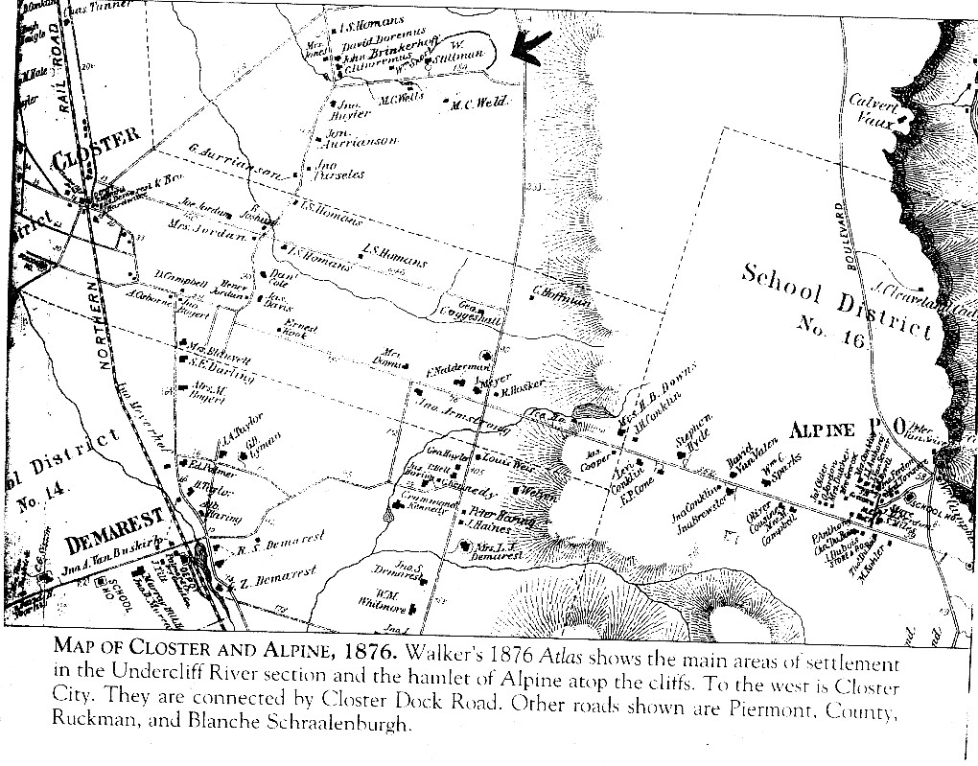

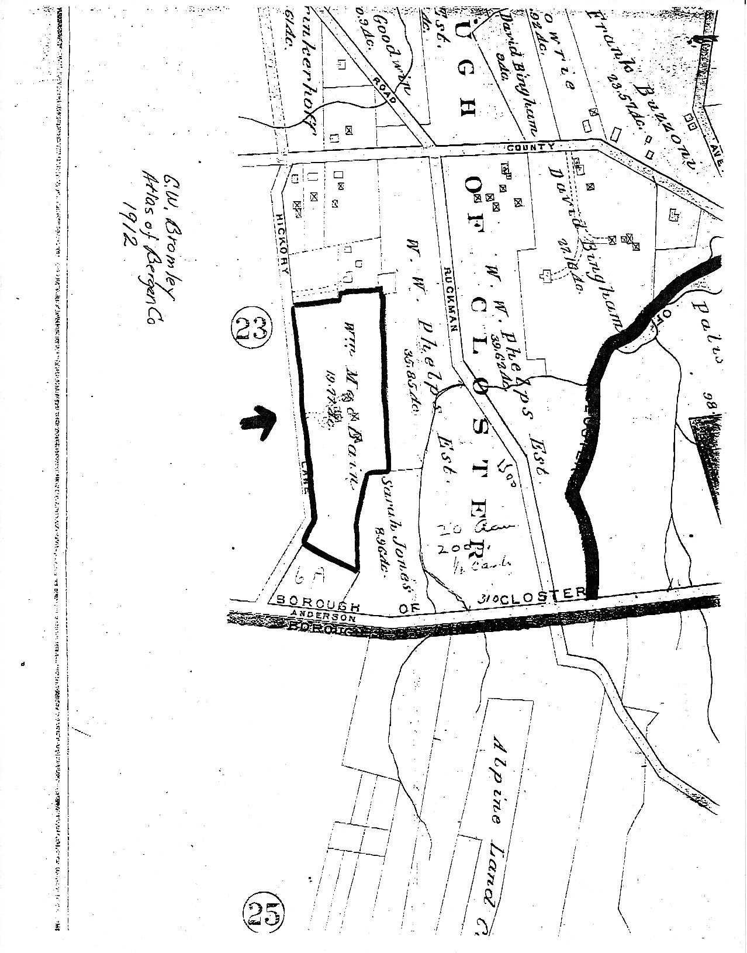
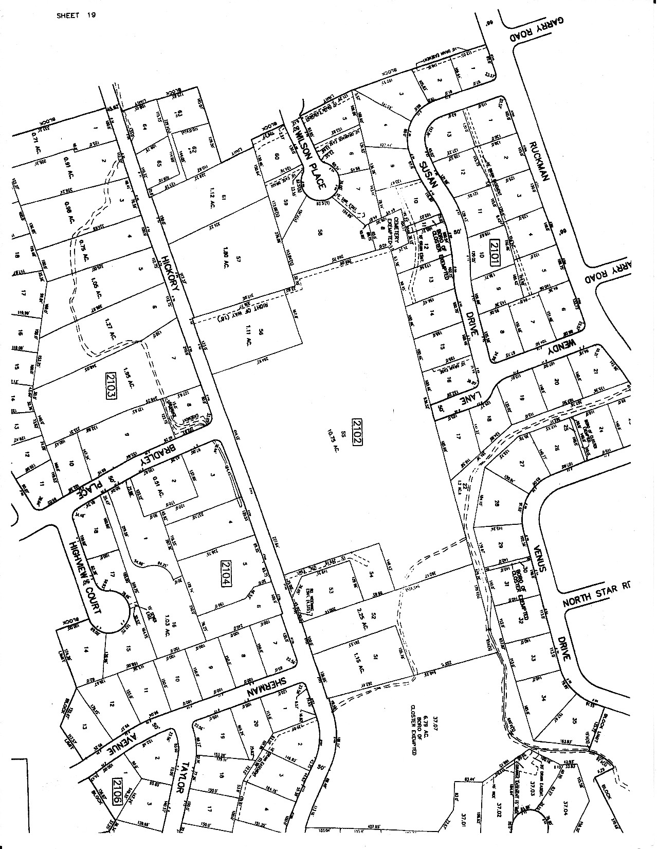
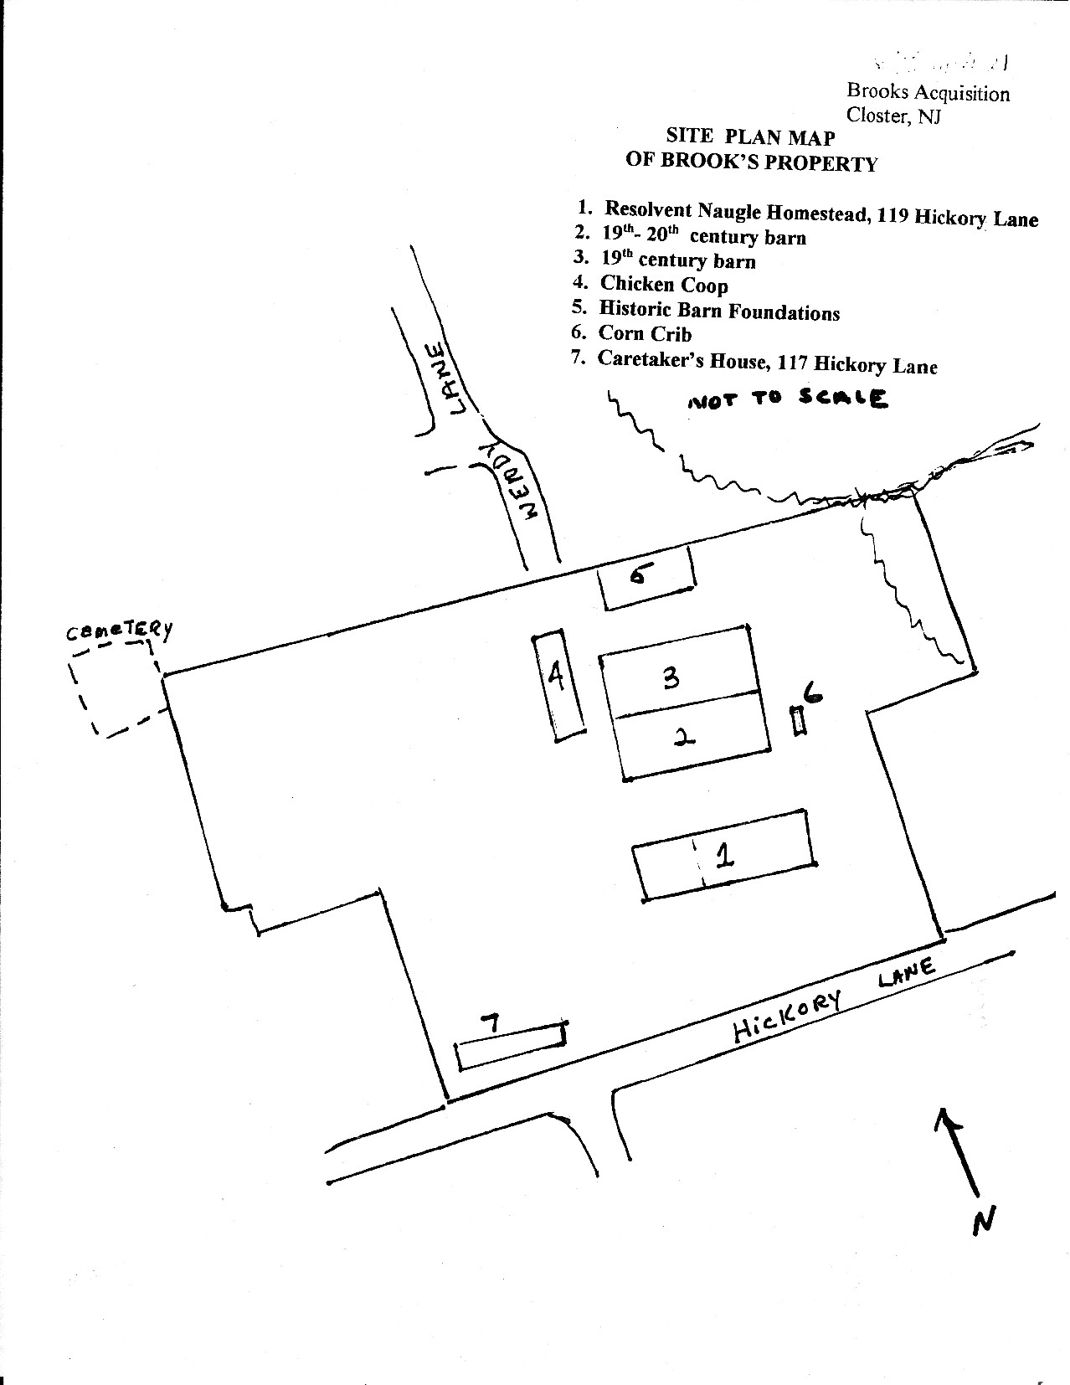

PHOTOS – BUILDINGS ON BPROPERTY

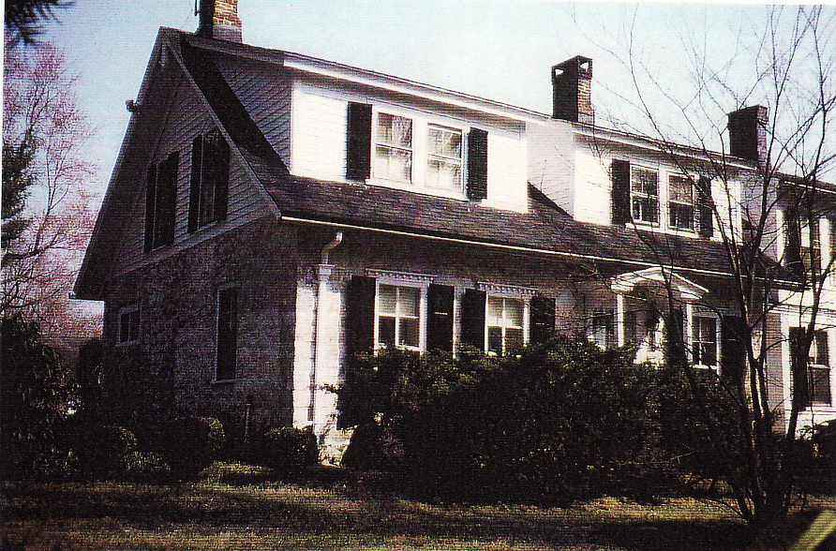

119 Hickory Lane
Resolvert Nagel House

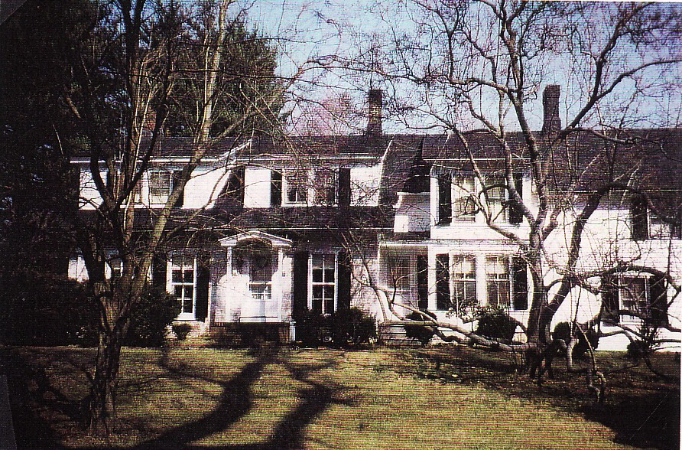
PHOTOS OF BUILDINGS ON PROPERTY – Barns & Corn Cribs – View West

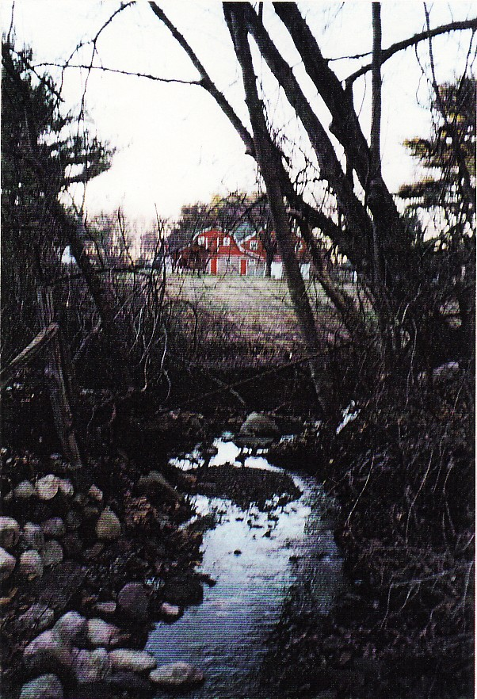

PHOTOS OF BUILDINGS ON PROPERTY – BARNS AND CORN CRIB VIEW WEST

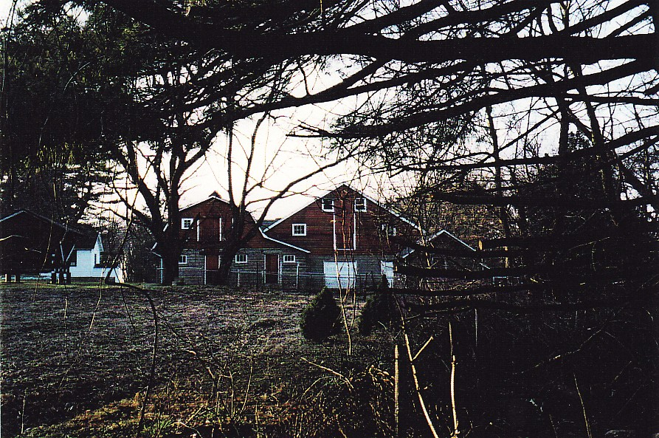

PHOTOS OF BUILDINGS ON PROPERTY
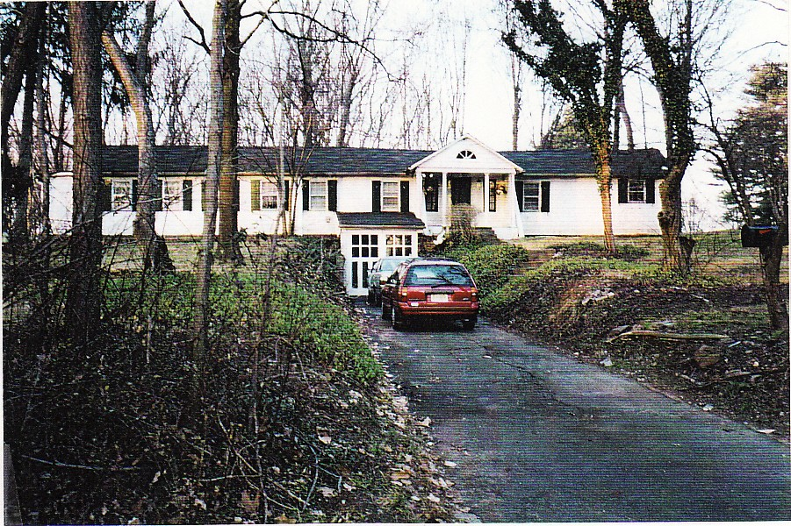

117 Hickory Lane – Caretaker’s House View North

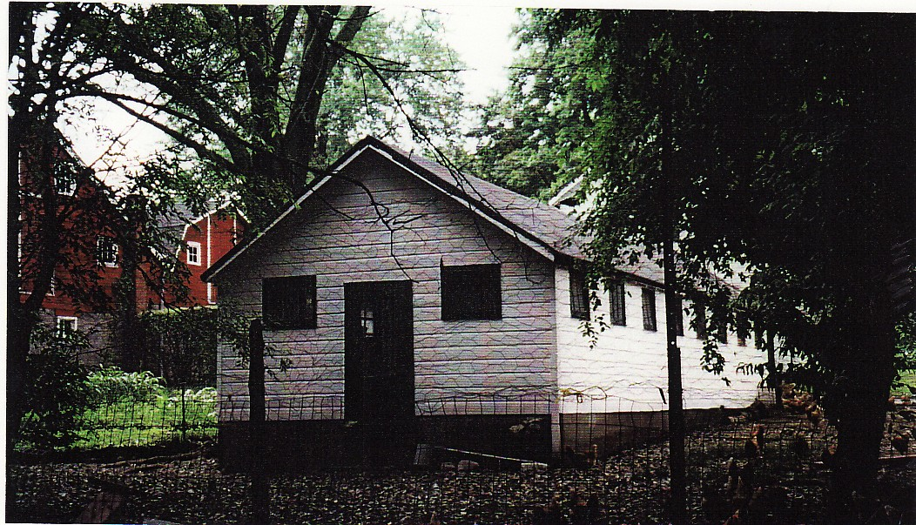

Chicken Coop

PHOTOS OF BUILDINGS ON PROPERTY

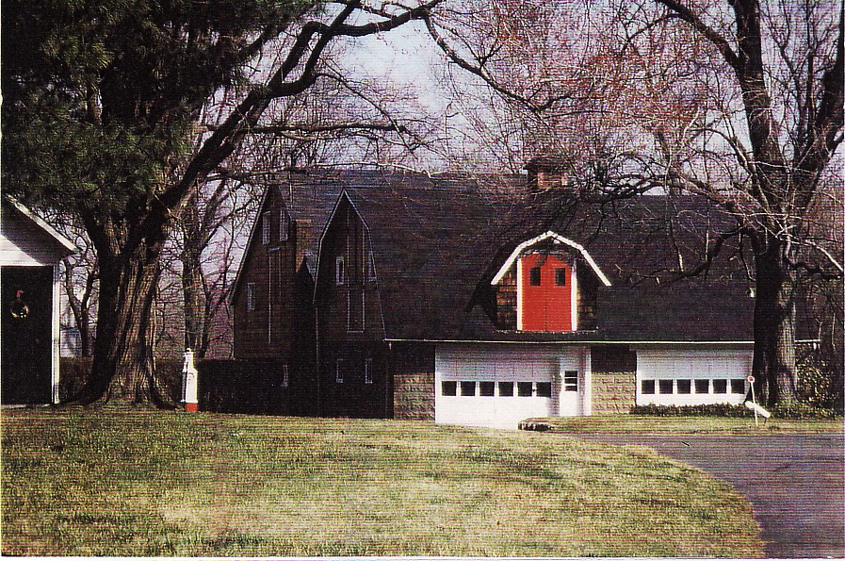

BARNS

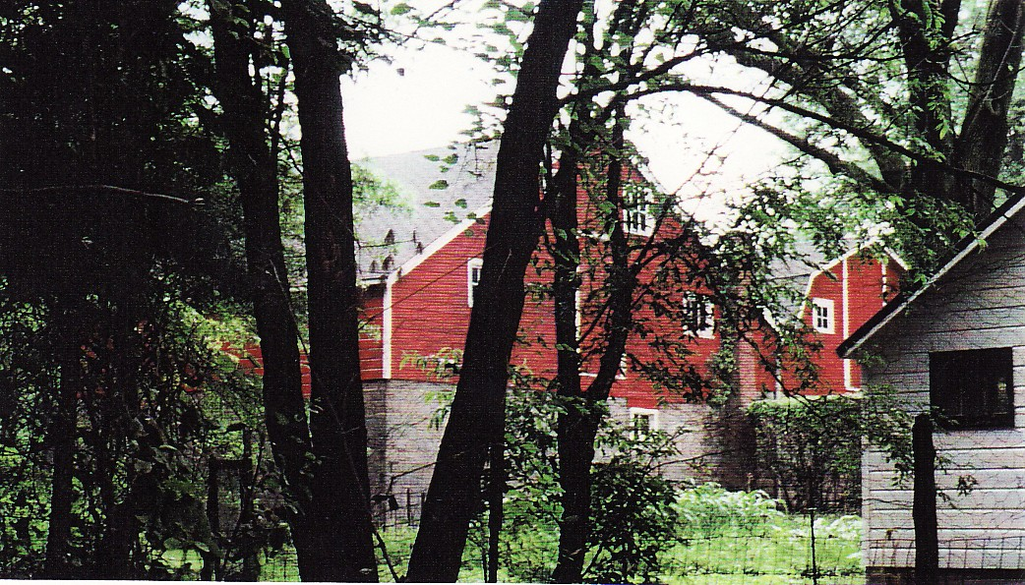

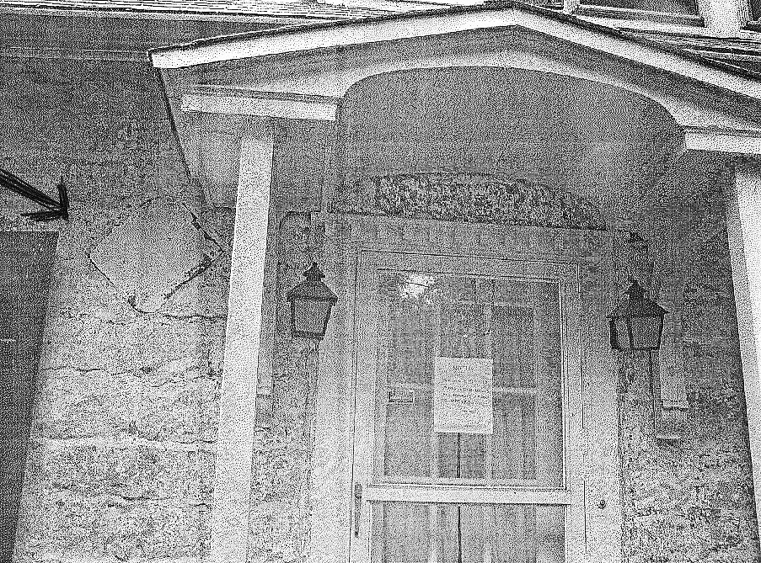

LOZENGE STONE NEAR FRONT DOOR OF RESOLVERT NAGEL HOUSE

(noted by arrow)

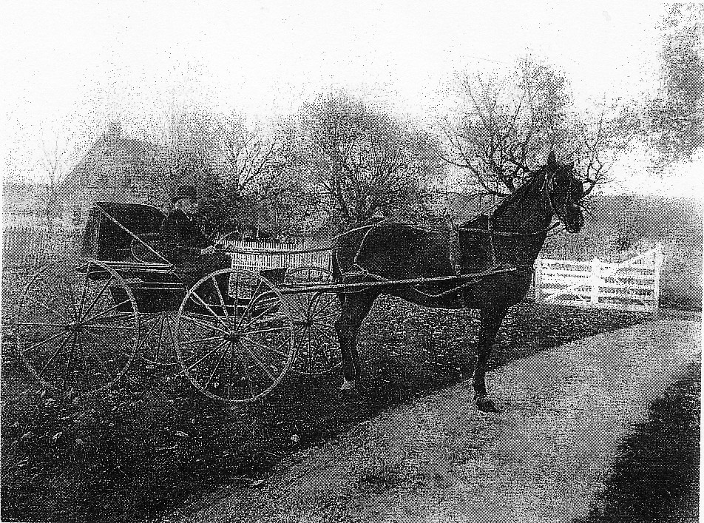

HISTORIC PHOTO – Abraham I. Auryansen in front of house at 119 Hickory Lane

This image was printed off a 19th Century glass negative.

From the Conklin collection, courtesy of the Closter Historical Society.

ADDENDUM

Additions and Corrections updating page four of the Nomination Report for the Resolvert Nagel House and Farm Complex

Page 4
Second Paragraph

A frame structure is located to the northwest of the house. This one room single story building is used for the storage of farm materials. There is an entry door on the front and a window on each of the four walls. To the rear of this structure is a wood frame entry way extension built into the bank of the rear grade which provides access to what is described as an ice house. The use of this structure as an ice house is very significant in that there are no other known ice houses in Closter, or in Bergen County.

Third Paragraph

A structure currently used as a caretaker’s house (117 Hickory Lane) is situated to the far southwest corner of the property. This long, low frame structure measuring 78’ by 12’ has been described from various sources (oral histories) as previously a kennel used by the MacBains or a bunk house for farm workers. Either described original use of the structure is significant to the farm complex and the history of Closter. The kennel use relates significantly to the MacBain history of the site, and the importance of several well known Closter area kennels in the first half of the 20th Century. (The historic property at 377 Piermont Road was home to the Hazelhead Kennels at this time, and its administrator was secretary of the Bergen County Kennel Club.) The bunk house use is even more significant as it bespeaks of the history and story of farm labor within Closter and Bergen County (no other farm worker bunk house is known to exist). Further research, including close inspection of the building, would be helpful. This structure has been slightly altered to give the impression that it was always intended to be a single family dwelling. A classical revival portico provides a stately entry way. Other alterations include decorative shutters and an excavated “basement” garage.

